Model Diagnostics and Robustness Tests for “Is Older Music Becoming Dominant in the Age of Streaming?”
This additional document covers the core components of Bayesian modelling rigour, as outlined in (Kruschke, 2021). Figure 1 presents the prior and posterior predictive checks on the log1p streams scale. In line with Gelman et al. (2017), prior predictive checking was used before fitting to assess whether the weakly informative priors generated plausible stream-count distributions under the observed covariate structure. The observed distribution fell within the range of prior replicated distributions, indicating that the prior-likelihood combination did not rule out the observed data-generating range. The posterior predictive overlay showed that the simulated densities closely followed the observed distribution across the main body of the data, including the central peak and overall spread. The remaining mismatch was modest and concentrated in the upper tail, where the observed density retained slightly more mass than most replicated densities. Overall, the checks suggest that the priors were not too restrictive before fitting, and that the fitted model reproduced the logged stream-count distribution reasonably well.
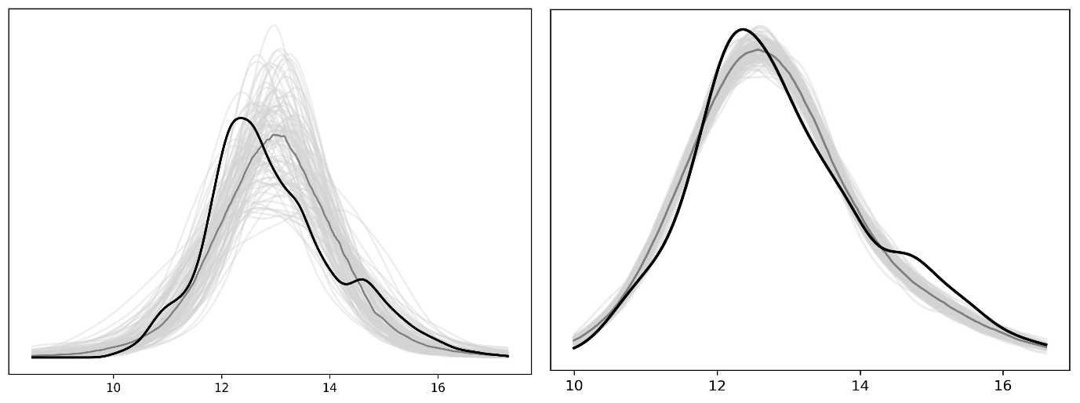
Figure 1. Prior and posterior predictive checks. The left panel shows the prior predictive check and the right panel shows the posterior predictive check. In each panel, the black line shows the observed density of the dependent variable on the log1p streams scale, the light grey lines show 100 simulated predictive densities, and the dark grey line shows the median simulated density.
Next, the model was refitted with a wider prior to assess whether the results were sensitive to the weakly informative prior. The wider prior did not change the signs of the fixed-effect posterior means, the credible-interval conclusions, or the main findings for age, time, country and their interactions. Some three-way age-by-month interactions shifted slightly, particularly for Germany, Japan and Turkey, and the random-effect precision was lower, indicating slightly less shrinkage of song-level effects. However, these changes did not alter the direction or interpretation of the results.
Finally, we assessed robustness to the observation model by refitting the model under a simpler Gaussian likelihood, which removes the additional heavy-tail flexibility of the preferred mixed Gaussian specification, and under a non-Gaussian Gamma likelihood, while keeping the fixed-effects structure, random-effects structure and priors unchanged. The substantive conclusions were stable across these alternative specifications. In all three models, the main effect of track age remained negative and the age-by-time interaction remained positive.

References:
Gelman, A., Simpson, D., & Betancourt, M. (2017). The Prior Can Often Only Be Understood in the Context of the Likelihood. Entropy, 19, 555. https://doi.org/10.3390/e19100555
Kruschke, J. K. (2021). Bayesian Analysis Reporting Guidelines. Nature Human Behaviour, 5(10), 1282–1291. https://doi.org/10.1038/s41562-021-01177-7

